Day in the Life of the Hudson River 10/13/22
Brooklyn Bridge Park, Brooklyn NY
Pier 1, Pebble Beach, Pier 1 (East River)
EAST RIVER MILE: 2.4
Salt Front: ~ RM 76
Packer Collegiate Institute – Jessica Genter & 7th grade
73 students & 9 adults
Latitude 40.70445 N & Longitude – 73.99373 W
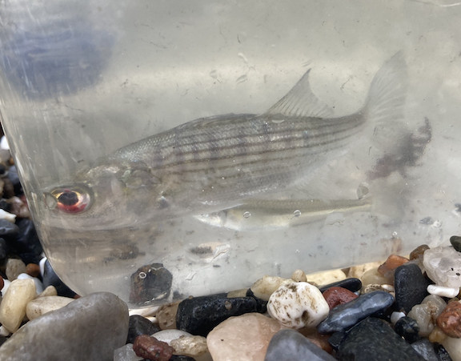

Bridge Park, Brooklyn, NY
Area: Developed set of piers with some grass.
Surrounding Land Use: 70% Urban/residential; 20% Industrial/commercial; 10% beach Sampling Site: South of boat marina and in front of the soccer field.
Shoreline: Beach, Riprap
River Bottom: Sandy, Muddy, Rocky
Water: calm
*NR = Not read/recorded
ITEM |  | Time |  | Reading |  |  |  | Comments
Physical
Air Temperature- |  | 11:03 AM |  | 21.9°C |  |  | 71.4°F
Wind Speed: |  | 11:03 M |  | Anemometer  1.1 m/s |  |  | Beaufort  3 | Direction  SW
Weather today |  | 11:03 AM |  | >75% cloud cover |  |  | No Rain
Weather the past 3 days: |  | Sunny and dry- high 60s
Tides- measured pier to the water |  | Time |  | Rising, Falling, Unchanged |  |  | Water Height (cm)
 |  | 9:35 AM-  10:20 AM  11:04 AM  1:19 PM |  | Rising  Rising  Rising  Falling |  |  | 252 cm  244 cm  235 cm  252 cm
Current- |  | Time |  | Cm/sec |  | Knots | North/South | Ebb/Flood/Still
*N/S not recorded but  with rising tide would  expect flooding? |  | 9:55 AM |  | 38.5 |  |  | ? | Ebb*
 |  | 10:30 AM |  | 71.46 |  |  | ? | Ebb*
 |  | 11:18 PM |  | 22.7 |  |  | ? | Ebb*
Water Temperature- |  | 10:45 AM |  | 18°C |  |  | 64.4°F
Turbidity- Long Sight Tube (120 cm) |  | 11:00 AM |  | 89 cm
Chemical
Salinity-Hydrometer |  | 11:00 AM |  | 24 ppt
Standardized Salinity – NR
DO – Lamotte Drop Count Kit |  | Time  11:00 AM |  | Temp  18°C |  |  | ppm DO  6 ppm | % saturation  NR
pH – Color Match Kit |  | 11:00 AM |  | 8
Nitrates- NR
Phosphates- NR
Alkalinity- NR
Biological-
Fish – Seine |  | Number |  | Name |  |  | Length of longest | Length of smallest
9:30 AM- 2:30 PM |  | 126  1 |  | Atlantic Silverside  Striped Bass |  |  | 9.5 cm  10 cm | 3.5 cm
Fish Totals |  | TOTAL: 127 |  | Diversity: 2
Macroinvertebrates |  | Number |  | Name |  |  | Length of longest | Length of smallest
 |  | 14  4 |  | Ctenophore spp.  Moon Jellies
Macroinvertebrate Totals |  | TOTAL: 18 |  | Diversity: 2
Sediment Core – NR
Length | H2S smell |  | Oxid Top |  | Oil |  | Grain Size | Other Features
Boats- NR
 | Time |  | Name |  | Color |  | North/Southbound | Light/Loaded
Commercial
Recreational

